CCLive Messenger

About this project:

RoadMap:

- Frontend:

- Logo

- login page

- register page,

- Landing Page,

- main-page

- Backend:

- Log-in,

- register logic,

- LoggedIn

- Websocket ?? online, offline etc., sending, receiving.

- Admin (Bann users)

- Database for users, and messages. ( sender user id, receiverUser id, message, Time)

websocket: <https://developer.mozilla.org/en-US/docs/Web/API/WebSockets_API/Writing_WebSocket_client_applications>

Landing Page:

* Login button, Registration button, Welcome text.

Login Page:

* email, password 🡪 input field
* Login button
* Registration button
* (forgott password button)
* Authentication

Registration Page:

* username, email, password
* register button
* you are already register? button

Main page:

* profil szerkesztése gomb
* (profil üzenet mint a messengerben)

Admin page:

* összes User gomb 🡪 Fetch display all user and one search tab.
  + can delete user
  + can change default theme

Userpage:

* change profile picture, cover photo, display name etc.
* Some „about me ” text.

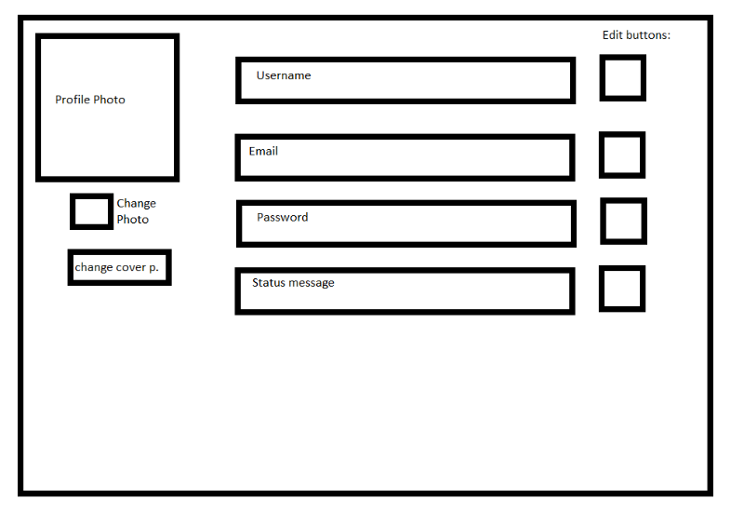

Main Page Basic plan:

* 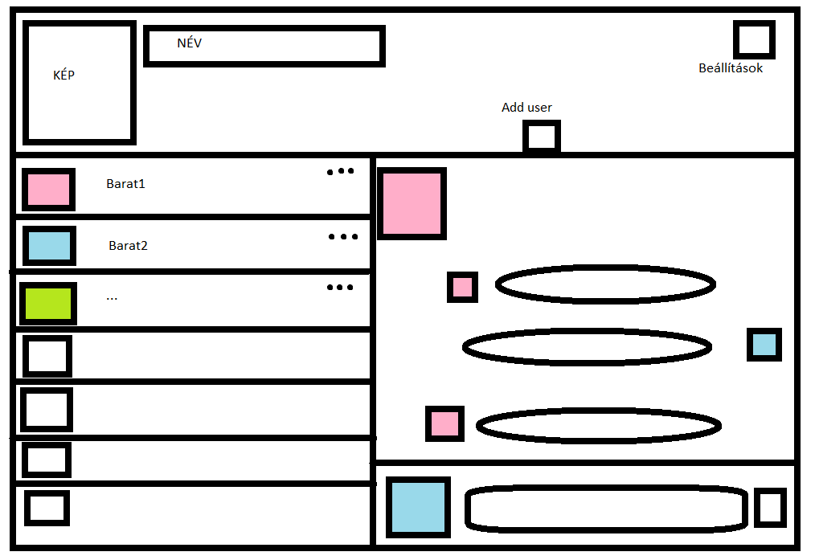Settings,
* Add friend
* delete friend(drop down menu next friend)
* Block friends
* double click for open chat.
* Send button
* logout button